**EXERCISE NO:** 8

**REGISTER NO:** 1518102072

**DATE:** 20.11.20

**AIM:**

To write a python program to get list,sorted in incresing orderby the last element in each tuple from the given list of non empty tuples.

**PROGRAM:**

lst=[]

list1=int(input("Enter no. of elements:"))

for x in range(0,list1):

val=int(input())

lst.append((val,pow(val,3)))

lst1=sorted(lst)

print(lst)

print(lst1)

**LINK:**

**http://103.53.53.18/mod/vpl/forms/submissionview.php?id=317&userid=1686**

**OUTPUT:**

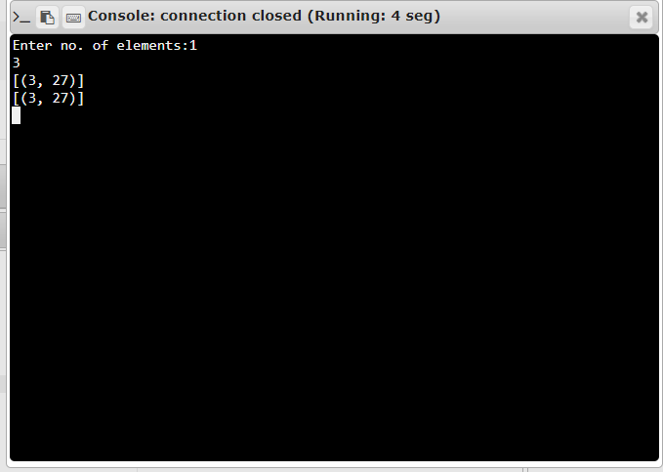

**RESULT:**

Thus the program is executed successfully and the output is verified.